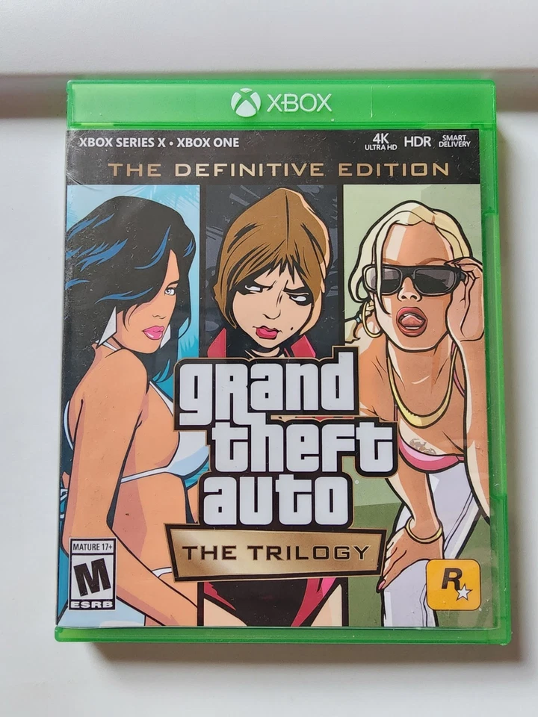

**Grand Theft Auto GTA:**

**1️. Remastered Classics**

Includes **GTA III, GTA: Vice City,** and **GTA: San Andreas** with updated visuals and controls for modern platforms.

**2️. Enhanced Graphics**

Features improved **lighting, textures, character models,** and more detailed environments for a refreshed look.

**3️. Modernized Controls**

Updated **aiming, shooting, and navigation** mechanics, making gameplay smoother and more like **GTA V**.

**4️. Quality-of-Life Upgrades**

Introduces **autosave, improved minimaps,** and better mission tracking for a more user-friendly experience.

**5️.Mixed Reception**

The game launched with **bugs and glitches**, but later patches and updates improved performance and stability.